CLINIC QUEUE & TOKEN MANAGER
@CREATIVITY THINK (9483175986/7019689991)

ABSTRACT:
Clinic Queue & Token Manager is a dynamic web-based application designed to streamline the patient queue and appointment token system in clinics, labs, and diagnostic centers. The system enables patients to book tokens online, track live queue movement, receive notifications, and reschedule or cancel appointments easily. For clinics and doctors, it provides real-time queue control, slot configuration, performance analytics, and day-wise reporting. Built using Django REST Framework for the backend and React with Redux for the frontend, this solution delivers a modern, efficient, and fully digital clinic flow management experience..

INTRODUCTION OF THE PROJECT:
Traditional clinic queues often lead to long waiting times, manual token handling, and overcrowded reception areas. This project eliminates these inefficiencies by automating the token generation and queue progression process. Patients can view their estimated wait time, track queue movement in real time, and receive alerts when their turn is near. Clinic staff can easily manage tokens, skip or pause queues, set working hours, and analyze patient flow patterns. The system’s digital approach reduces stress for patients, improves service quality, and enhances the overall operational efficiency of medical facilities..

PROJECT OBJECTIVES:

• Allow patients to book clinic/doctor tokens online
• Show estimated time, current queue status, and live updates
• Provide alerts: “Your turn soon”, “Token moved”, and “Queue paused”
• Enable easy rescheduling or cancellation of appointments
• Offer clinics the ability to configure working hours and slot intervals
• Allow staff to manage queue movement: next, skip, pause, resume
• Provide analytics including patient flow, peak hours, and average waiting time
• Generate downloadable daily reports for record maintenance
• Reduce crowding and manual errors at clinics and diagnostic centers

PROBLEM OF THE STATEMENT:
Clinics often face challenges like long queues, unpredictable waiting times, and manual token management, which cause patient dissatisfaction and operational inefficiency. Patients frequently visit the clinic physically just to check their position in the queue, resulting in unnecessary crowding. The Clinic Queue & Token Manager solves this by digitizing the entire process—token booking, live queue status, notifications, and rescheduling—while offering clinics powerful tools for queue control and analytics..

MOTIVATION OF THE PROJECT:
• To reduce patient waiting stress and physical queue crowds
• To modernize clinic operations with a digital appointment/token model
• To provide real-time visibility for both patients and doctors
• To automate routine tasks like token moving, pausing, or skipping
• To enable data-driven insights such as peak hours and average wait times
• To support clinics in improving workflow, efficiency, and patient service quality
• To promote hygienic queue management in medical environments

BLOCK DAIGRAM OF PROJECT:

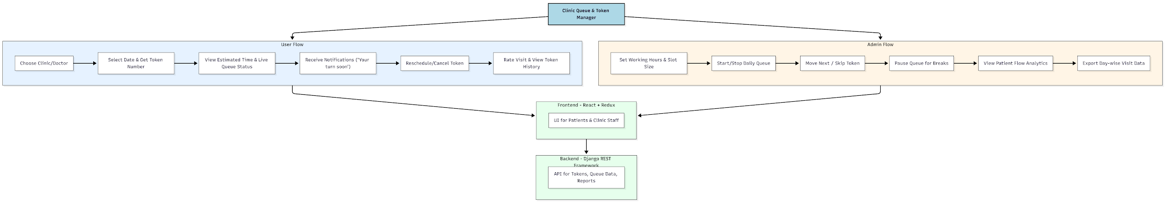

WORKING OF THE PROJECT:
Patients access the web application and select their desired clinic or doctor. After choosing a date, the system generates a token number along with an approximate time. Users can track real-time queue updates, receive “your turn soon” notifications, and reschedule or cancel if needed.
Clinic staff use the dashboard to configure work hours, manage queue actions such as next/skip/pause, and view analytics. The backend stores queue data, patient flow, wait times, and generates day-wise reports. The frontend provides an easy, responsive interface for both patients and administrators..

SOFTWARE REQUIREMENT:
- Backend:
  - Python 3.x
  - Django
  - Django REST Framework
  - SQLite/PostgreSQL
- Frontend:
  - Node.js and npm
  - React.js
  - Axios
- Development Tools:
  - Visual Studio Code
  - Postman (for testing APIs)
  - Git/GitHub (for version control)
- Server/Deployment (Optional):
  - Gunicorn, Nginx, or Heroku/AWS for hosting

ADVANTAGES OF THE PROJECT:

• Eliminates physical queue waiting and overcrowding
• Real-time queue tracking for patients
• Reduces manual work for clinic staff
• Improves patient satisfaction and clinic efficiency
• Provides analytics for better decision-making
• Supports rescheduling and cancellation flexibility
• Faster token processing with digital queue controls
• Generates daily reports for records and audits

APPLICATIONS OF THE PROJECT:
• Clinics
• Diagnostic laboratories
• Hospitals and outpatient departments
• Physiotherapy and specialty centers
• Eye & dental clinics
• Blood testing and scan centers

REFERENCES:

- Django REST Framework Documentation — Django Software Foundation. Django Documentation. Available: https://docs.djangoproject.com/
- Django REST Framework. DRF Documentation. Available: https://www.django-rest-framework.org/
- React. React Official Documentation. Available: https://reactjs.org/docs/getting-started.html
- Redux. Redux Documentation. Available: https://redux.js.org/introduction/getting-started
- PostgreSQL Global Development Group. PostgreSQL Documentation. Available: https://www.postgresql.org/docs/
- MySQL. MySQL Reference Manual. Available: https://dev.mysql.com/doc/
- Git. Git Documentation. Available: https://git-scm.com/doc
- Node.js. Node.js Documentation. Available: https://nodejs.org/en/docs/
- Axios. Axios Documentation. Available: https://axios-http.com/docs/intro
- Socket.io Documentation – https://socket.io/docs/

